User Stories

Team 7

Ilgiz Mustafin  
Amir Gimaev  
Mikhail Sheinberg

|  |  |
| --- | --- |
| **Terminology** | |
| Request | |
| Request | request for cleaning with specified   * date * time * room number * status |
| Approved | request is checked by admin, and cleaning service will arrive in specified time |
| New | request is registered and waiting to be checked by administrator |
| Denied | request is checked by admin and can`t be served for some reasons |
| Done | request was fulfilled |
| Roles | |
| Client | Innopolis student, who live in dorms |
| Administrator | Dorm administrator or another official |
| Cleaning | Specialists who are responsible for cleaning of rooms |

|  |  |
| --- | --- |
| **Use Case Name** | **Sign Up** |
| Actors | Client |
| Pre-conditions | User filled the sign up form |
| Flow of events | 1. Systems checks that there is no account registered with the provided login 2. System creates an account with the provided client information (name, login, password) |
| Post-conditions | User is registered and can Sign In with the provided credentials |
| Alternate flows and exceptions | 1. System finds an account with the provided login 2. System shows a message that a user with the provided login is already registered 3. User is not registered 4. Account is not created |

|  |  |
| --- | --- |
| **Use Case Name** | **Sign In** |
| Actors | Client or Administration |
| Pre-conditions | User enters their crls in the Sign In form |
| Flow of events | 1. System checks that there is an account with the provided login and password 2. System considers the client as signed in |
| Post-conditions | User is Signed In |
| Alternate flows and exceptions | 1. System does not find an account with the provided login and password 2. System shows a message that there is no user registered with the provided login and password combination 3. User is not signed in |

|  |  |
| --- | --- |
| **Use Case Name** | **Request for Cleaning Creation** |
| Actors | Client |
| Pre-conditions | Signed in client creates a new request for cleaning, specifying the date and time when the cleaning should be performed, room number. The time should be in the range from 10 am to 6 pm |
| Flow of events | 1. The system creates a request with the specified date, time and room number. The status of the order should be “New”. |
| Post-conditions | * Request with the specified data is created |
| Alternate flows and exceptions | 1. If user have specified time not in the range from 10 am to 6 pm, the request is not created and the error message is shown 2. Request is not created |

|  |  |
| --- | --- |
| **Use Case Name** | **Request status change** |
| Actors | Administration |
| Pre-conditions | Admin selects the new status for the request and enters the comment message |
| Flow of events | 1. System updates the request with the new status 2. Email is sent to the client who created this request containing the new status and the comment message. Also, there is the help text telling that a new request can be created using the system |
| Post-conditions | * Request is updated with the selected status * Email is sent with the new status and the entered comment message |

|  |  |
| --- | --- |
| **Use Case Name** | **Feedback on the cleaning filling** |
| Actors | Client |
| Pre-conditions | Client fills the feedback form for a “Done” request |
| Flow of events | 1. Client chooses grade the service 2. Client submit the feedback comment 3. System stores the grade and the feedback comment for the request |
| Post-conditions | * Cleaning service feedback is saved for the request |

|  |  |
| --- | --- |
| **Use Case Name** | **Admin Panel Request List** |
| Actors | Admin |
| Pre-conditions | Signed in admin opens the admin panel |
| Flow of events | 1. System shows all requests |
| Post-conditions | * Admin sees requests in the admin panel |

|  |  |
| --- | --- |
| **Use Case Name** | **Change of Language** |
| Actors | Client, Admin |
| Pre-conditions | User selects a language (Russian or English) |
| Flow of events | 1. System shows system text in the selected language for this user |
| Post-conditions | * System text is shown in the selected language |

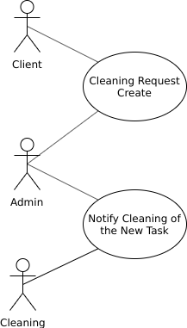

System Scope

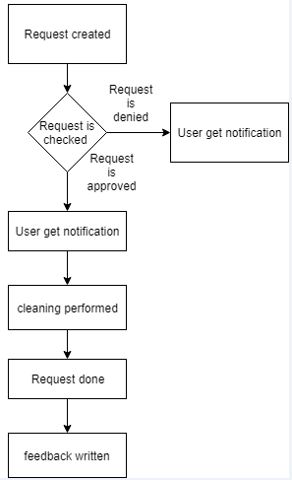

Activity diagram